ESI is typically lowest around the months of April, May, and June. The low ESI values can be explained by both a decrease in ET and an increase in PET. Likewise, high ESI values in December and January can be explained by high ET and low PET values during those months.

ET averages (2000-2024)
Month | Median | Min | Mean*
January** | 5.16 | 3.42 | 52.8
February | 4.35 | 2.74 | 47.6
March | 3.28 | 1.46 | 46.6
April | 2.48 | 0.662 | 45.8
May | 2.5 | 0.461 | 46
June | 2.39 | 0.456 | 46.2
July | 3.34 | 1.13 | 47.3
August | 4.09 | 1.3 | 47.9
September | 4.04 | 1.62 | 47.5
October | 3.47 | 1.99 | 46.7
November** | 4.09 | 2.84 | 52.2
December | 4.39 | 3.15 | 47.6
*No-data values are listed as 3276.6, messing up the mean value
**Missing data for the southwestern part of New Mexico

PET averages (2000-2024)
Month | Median | Min | Mean*
January** | 24.7 | 9.51 | 71.4
February | 32 | 11.6 | 74.2
March | 44.9 | 22.7 | 87.2
April | 57.5 | 37.4 | 99.7
May | 64.6 | 52.6 | 106.9
June | 69.2 | 57.1 | 111.4
July | 62.9 | 50.3 | 104.9
August | 58.1 | 46.8 | 100.2
September | 49.5 | 39.1 | 91.9
October | 38.7 | 28.5 | 81.6
November** | 29.1 | 17.8 | 76.8
December | 21 | 9.47 | 63.6
*No-data values are listed as 3276.6, messing up the mean value
**Data in southwestern part is questionable

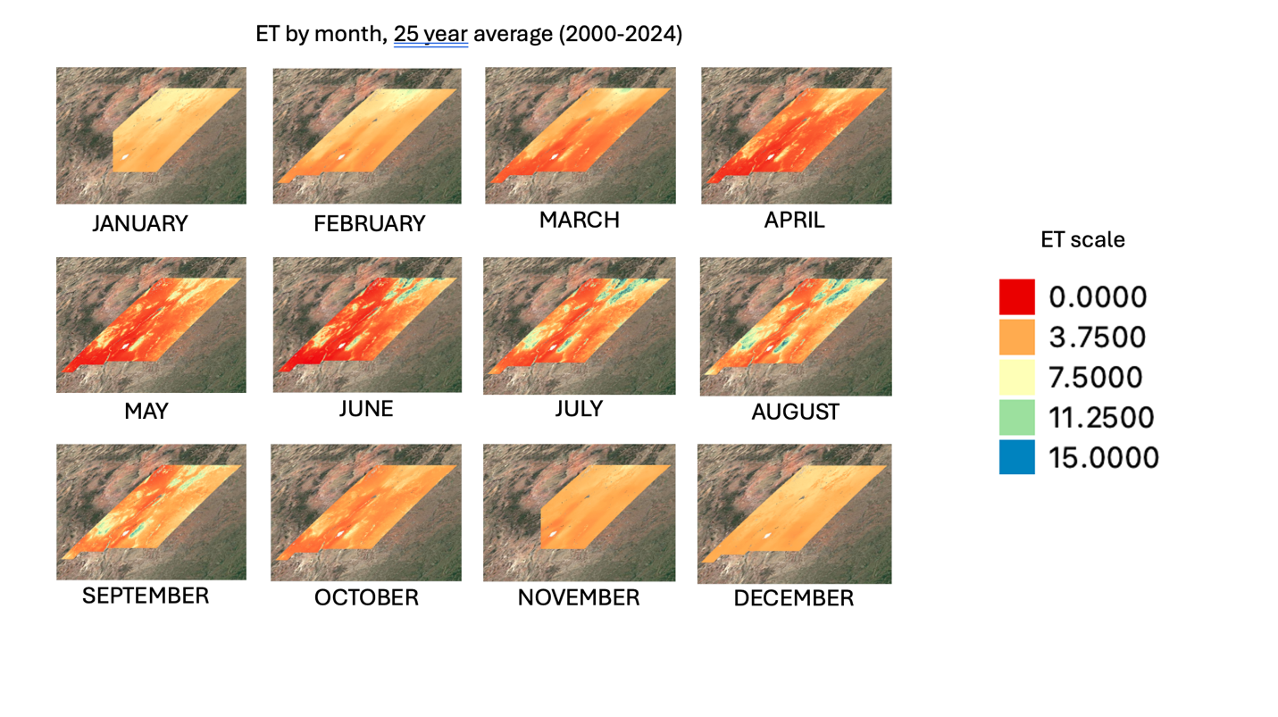
ET in most regions was higher in the fall and winter, however in specific regions ET was much higher between June and September.
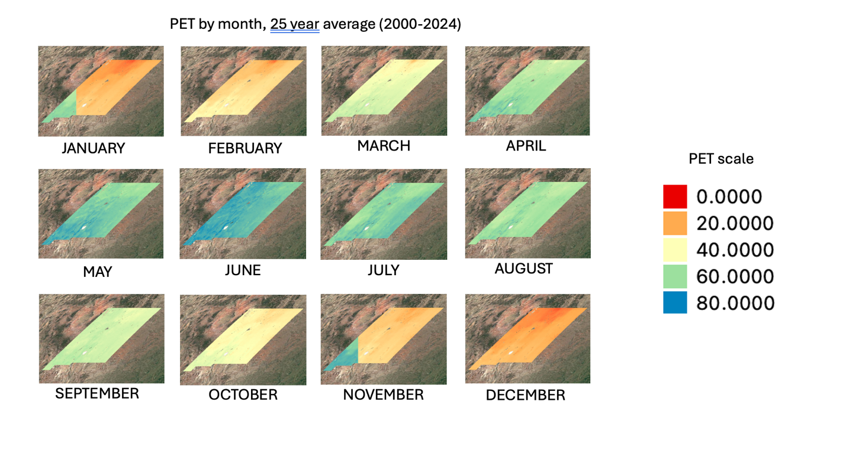
PET was highest between the months of April and September.

